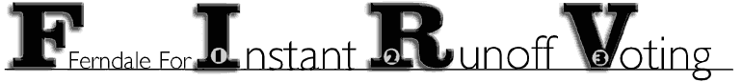
Box 20076, Ferndale, MI 48220 . Phone: 248-336-9241 . Web: http://www.firv.org
Email: contact@firv.org

Statements in Support of Instant Runoff Voting for Ferndale’s Mayoral Elections

- "Instant Runoff Voting is an excellent way to further democratize elections, allowing candidates with the most appeal to gain majority support even with third or fourth party spoiler candidates. Ferndale could be a great place to test the IRV process." - Craig Covey, Ferndale City Councilman.

- “What you are doing here with Instant Runoff Voting is a part of a necessary revolution towards a human-scaled politics. I encourage you to make it work here, and then spread it to other communities from here. I wish it were in place for this election!" – Doris “Granny D.” Haddock

- ”True democracy is alive when citizens have real choices, and Instant Runoff Voting seems to be common sense for voters who want to vote their conscience." - Sean Kosofsky, Director of Policy for Triangle Foundation

- “Many of our states use runoffs, but voters have to return to the polls. Several cities in the West reportedly are planning to adopt the instant system this year. Right here in Oakland County, the progressive city of Ferndale is strongly considering that type of voting. The nation certainly should adopt the change.” - Neil Munro, February 26, 2004 in Nader's Candidacy Points to Need for Instant Runoff Voting in The Oakland Press

- “Instant Runoff Voting is an idea that clearly deserves a try, and small diverse cities like Ferndale are often the best laboratories of democracy." – Jack Lessenberry

